CS 3307-01 Operating Systems 2

Instructor: Professor Olawale Omoyeni

Name: Anonymos

Written Assignment Unit 4

**Introduction**

Editor programs are indispensable tools for editing text files and code, making them particularly vital for programmers and system administrators. Among these tools, Vim stands out for its high customizability and efficient operability, gaining widespread use. Although lightweight and multifunctional, Vim can initially be challenging for beginners to master. However, once learned, it becomes an incredibly powerful tool.

This document aims to provide an accessible explanation of the fundamental concepts of editor programs, using Vim to edit ASCII and binary files as practical examples. ASCII files are a human-readable format commonly used for configuration and log files. In contrast, binary files are used for executable or data files, requiring careful handling during editing. By focusing on these two file formats, readers can better understand the wide range of applications Vim offers.

Specifically, this document will explain Vim's basic operations and mode transitions and illustrate the characteristics and editing methods for each file type through concrete examples. Additionally, screenshots of operational steps will be included to visually convey the actual user experience.

This document aims to serve as a practical guide for beginners taking their first steps toward effectively learning Vim.

**About ASCII Files**

**What is ASCII?**

ASCII (American Standard Code for Information Interchange) is a standard character encoding format used for handling text data. It defines 127 characters, including alphanumeric characters and symbols, each represented by a 7-bit binary code. For instance, the letter "A" is represented as ASCII code 65 or in binary form as `01000001`. This simple and highly versatile specification serves as the foundation for text file formats. Since ASCII files are human-readable, they are ideal for storing unstructured text data such as configuration files and log files.

**Basic Operations for Editing ASCII Files**

Vim allows for efficient editing of ASCII files. Below are the fundamental steps for working with such files:

1. Opening a File

Enter the following command in the terminal to open an ASCII file:

vim filename.txt

2. Switching Modes

Vim operates in multiple modes, with the following being the most basic:

* Normal Mode: The default mode when Vim starts, allowing users to execute commands.
* Insert Mode: Press `i` to switch to this mode, enabling direct text input.

3. Editing and Saving

After editing text, press the `Esc` key to return to Normal Mode. Use the following commands for saving and exiting:

* Save only: `:w`
* Save and exit: `:wq`
* Exit without saving: `:q!`

4. Helpful Commands

* Displaying Line Numbers: Type `:set number` to display line numbers.
* Search Function: Enter `/keyword` to search for a keyword and press `n` to move to the next match.

**Characteristics and Applications of ASCII Files**

Due to their simplicity, ASCII files are widely used in various systems. For instance, Linux stores configuration files like `/etc/hosts` and `.bashrc` in ASCII format. Vim makes it easy to open and edit these files. Moreover, by leveraging features such as displaying line numbers and search functionality, users can quickly locate specific sections in large configuration or log files.

For example, to search for an error message in a log file, use the following commands:

vim logfile.txt

/ERROR

This approach allows you to pinpoint error locations quickly. By utilizing these features, editing ASCII files becomes both efficient and precise.

**About Binary Files**

**What is a Binary File?**

A binary file is a file format that stores data in a form directly understood by computers. Data, including characters and numbers, is represented as a combination of binary digits (0s and 1s). Unlike ASCII files, binary files are not easily readable by humans. Common examples of binary files include executable program files (e.g., `.exe`), image and audio files (e.g., `.png`, `.mp3`), and custom format data files (e.g., `.dat`).

When editing binary files, it is crucial to understand their data structure and file format specifications. Incorrect edits can corrupt the file or lead to unexpected behavior.

**Precautions When Editing Binary Files**

Vim provides useful features for editing binary files, but the process differs from standard text editing. Below are the essential steps and precautions:

1. Opening a Binary File

To open a binary file in Vim, use the `-b` option:

vim -b filename.bin

2. Viewing in Hex Mode

Since binary data is difficult to interpret directly, use Vim’s external command feature to convert the data into a Hexadecimal (Hex) format:

:%!xxd

This command displays the data in a readable Hex format, making editing easier.

3. Reverting to Binary Format

After completing edits in Hex mode, use the following command to revert the file back to its original binary format:

:%!xxd -r

4. Saving and Exiting

Save your changes and exit Vim using the following command:

:wq

**Practical Example of Binary File Editing**

A typical use case for binary file editing is modifying specific byte data. Below are two practical examples:

Changing Specific Bytes

Open the binary file in Hex mode, locate the desired byte, and modify its value. For instance, to change the second byte of the file to `FF`, find the target location and directly edit the value.

Replacing Specific Strings

Search for a string within the binary file and modify it. Use Hex mode to perform searches and replacements. For example, to find and modify the string "Hello," use the following command:

/48656c6c6f

These operations are particularly useful during tasks like debugging binary logs or executable files. However, it is strongly recommended to back up the original file to avoid unintended side effects.

**The Importance of Binary File Editing**

Editing binary files requires more expertise than editing text files but is crucial in system development and debugging. Tools like Vim empower users to efficiently and accurately manipulate binary data. With its robust functionality, Vim becomes an indispensable tool for handling complex binary file editing tasks.

**Basic Concepts of Vim and Usage for Beginners**

**Modes in Vim**

Vim is an editor program that operates in multiple modes, each enabling different functionalities. The three key modes beginners need to understand are:

1. Normal Mode

This is the default mode when Vim starts. In this mode, text is not directly entered; instead, commands for cursor movement and text editing are executed. For example, the `dd` command deletes the current line.

2. Insert Mode

Pressing the `i` key switches to Insert Mode, allowing direct text input. Once editing is complete, press the `Esc` key to return to Normal Mode.

3. Command-Line Mode

Press `:` to enter Command-Line Mode, where you can perform actions such as saving, searching, and modifying settings. For example, `:w` saves the file, and `:q` exits Vim.

Efficient use of Vim hinges on appropriately switching between these modes.

**Introduction to Basic Commands**

Here are some essential commands that beginners should learn first:

Text Insertion:

* `i`: Insert text at the cursor position.
* `o`: Open a new line below the cursor and insert text.

Cursor Movement:

* `h`: Move left.
* `j`: Move down.
* `k`: Move up.
* `l`: Move right.

Text Deletion:

* `x`: Delete the character at the cursor.
* `dd`: Delete the current line.

Saving and Exiting:

* `:w`: Save the file.
* `:q`: Exit Vim.
* `:wq`: Save and exit.

Practicing these commands is the most effective way to learn them.

**Vim Learning Tools**

For beginners, the built-in tutorial “vimtutor” is the best way to start learning Vim. Follow these steps to get started:

1. Open the terminal and type `vimtutor` to launch the tutorial.

2. Follow the guided lessons to practice basic operations.

“vimtutor” offers step-by-step explanations and exercises, enabling efficient mastery of Vim's essential functionalities.

**Customization and Extensibility in Vim**

Vim is highly customizable, catering to the needs of both beginners and advanced users. By editing the `.vimrc` configuration file, you can implement the following customizations:

* Displaying Line Numbers: Automatically apply `:set number` to show line numbers.
* Highlighting Search Results: Use `:set hlsearch` to make search results more visible.
* Adding Plugins: Extend functionality with plugins tailored to specific tasks.

These features elevate Vim beyond a basic text editor, transforming it into a powerful and versatile tool.

**Practical Examples and Screenshots**

**ASCII File Editing Example**

Here are the steps for editing an ASCII-formatted text file in Vim. These steps will help you understand the basic editing process:

1. Open a File

Enter the following command in the terminal to open a sample text file:

vim sample.txt

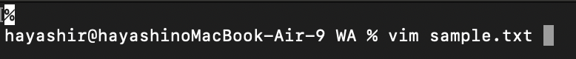

2. Insert Text

Press the `i` key to enter Insert Mode and type your text. For example, enter:

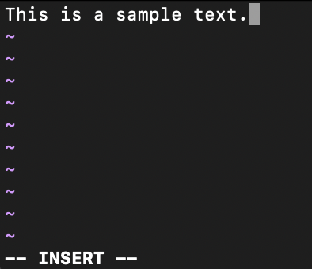

3. Save Changes

After editing, press the `Esc` key to return to Normal Mode. Use the following command to save your changes and exit:

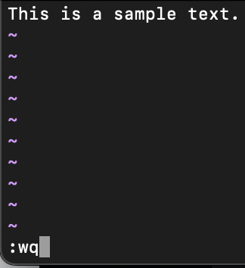

**Binary File Editing Example**

Next, here is an example of editing a binary file in Vim. These steps demonstrate how to perform basic editing in Hex format:

1. Open a Binary File in Vim

Run the following command in the terminal to open the file in Hex format:

vim -b sample.bin

Then convert the file to Hex format to inspect its contents:

:%!xxd

The file content will appear as follows:

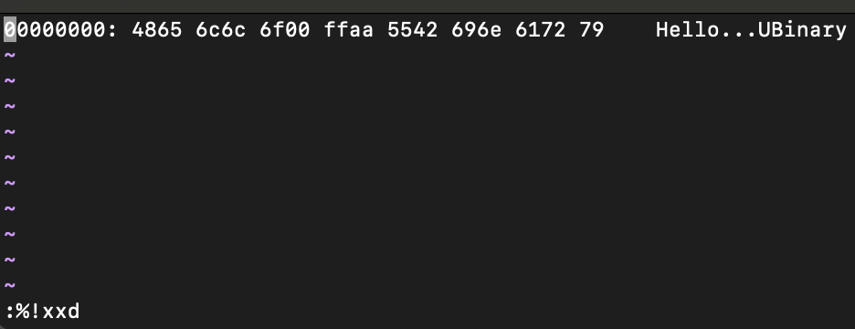

2. Edit Binary Data

For example, change the value `ff` to `ee`.

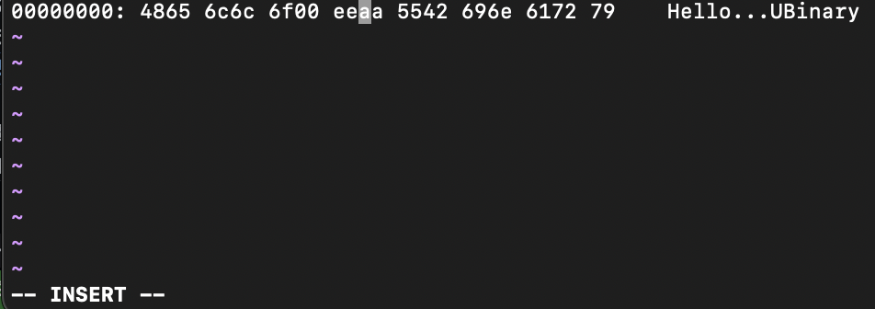

3. Revert to Binary Format

Once editing is complete, run the following command to revert the file to its original binary format:

:%!xxd -r

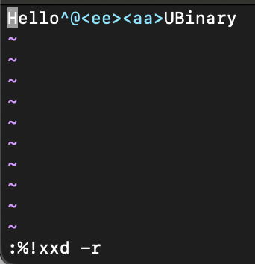

4. Save Changes and Exit

Save your changes and close Vim using the following command:

:wq

These steps illustrate how to edit binary files in Hex format effectively. Always proceed with caution when modifying binary data, as incorrect edits may corrupt the file.

**Conclusion**

This document provided a beginner-friendly explanation of editing ASCII and binary files using Vim. Vim is a highly flexible editor program capable of handling simple text editing and advanced binary editing tasks. While its efficiency and extensive features may seem daunting at first, users can unlock its full potential through consistent practice.

For ASCII files, users can easily edit human-readable data, such as configuration or log files, while utilizing features like line numbers and search functionality for efficient operations. For binary files, Hex mode allows users to edit specific data, demonstrating Vim's ability to meet advanced editing needs.

The key to learning Vim is hands-on practice and familiarization with basic commands and operations through trial and error. By starting small and gradually building skills—utilizing tools like “vimtutor”—users can transform Vim into an indispensable tool for daily tasks.

Furthermore, by leveraging Vim's customizability, users can optimize it for their workflows, satisfying the needs of both beginners and advanced users. It is hoped that this document helps readers effectively harness the power of Vim and realize its full potential.

Word Count: 1,735

References

1. Vim. (n.d.). *Downloading Vim*. Retrieved from https://www.vim.org/download.php
2. Emacs is sexy! (n.d.). *Emacs is sexy!*. Retrieved from https://emacs.sexy/